Question 1:

The given csv file STATISTICS.csv contains the required data. Write a function that does the following:

* Read the csv file
* Sort the csv data with respect to column “TFF” in ascending order
* Select the data only with MOLD_ID==D
* Divide “CT” column into different sections so that each wave has 25 values and for each section/wave, check if the wave is consistent or inconsistent.

**Definition of consistent:**

Red wave here is consistent

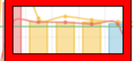

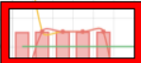

**Definition of inconsistent:**

The red wave indicate insistency

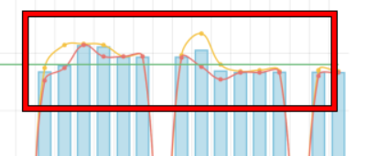

**Results:**

1-The results should be in the form of another column “CPP”, which contains label if a section is consistent or inconsistent. (1: consistent, 2: inconsistent)

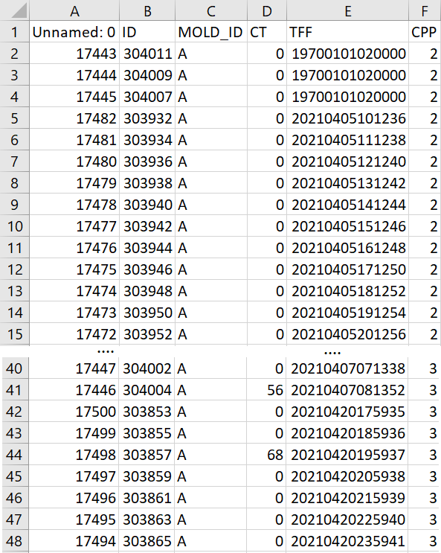

2- Also attach the images of each wave, labeled as consistent or inconsistent.

Question 2:

Write a generic function that checks whether following dates (given in the table) lies between date and time:

“20201201200530” and “20211201200530”. Note that all the date and time is in string.

| “20111201200530” |
| --- |
| “20211203095944” |
| “20211127235434” |
| “20211024202145” |
| “20211217183851” |
| “19711231223302 |
| “20211231232307” |
| “20191217182251” |

Note: For understanding, the string : “20211201200530” represents a date and time i.e. 2021/12/01 20:05:30

**Results:**

With test file attach the following:

1- code

2-a csv file containing the dates given above

3- a csv file containing whether the date lies within the given date or not. If it lies within a certain date, it should be labelled as: 1 else it should be labelled as 1.

# Image Processing section: weightage 40%

* Separate the circles depending on their radius and draw contour around the blob of color depending on radius from this image <https://www.cs.nmt.edu/~ip/images/Q4_4.tif>
* Draw sphere: -
  1. Make a numpy array of zeros of dimension 512x512x512
  2. Make a sphere in this matrix of desired radius
  3. Plot this sphere using matplotlib
* 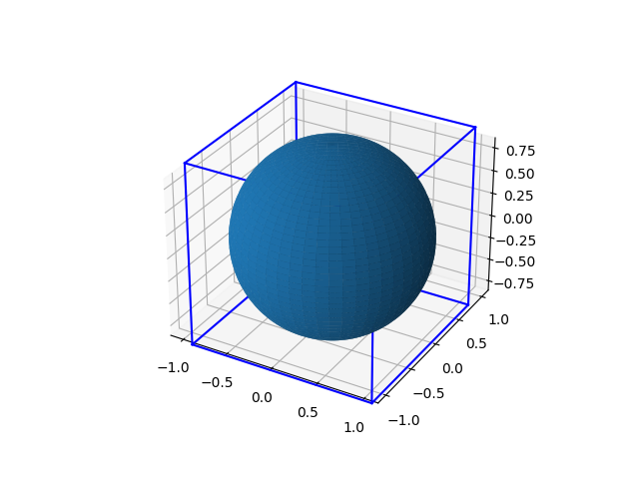

**Results:**

For each question:

1- attach the code

2- attach the result images if any

# Deep learning section: weightage 40%

Question 1: weightage 65%

* Make a simple 3d CNN classifier which can classify 5 classes and use layers according to your own desire
* Write a data generator function which takes in a path to video and from which frame to start it and label
* Then read 10 frames of that video starting from frame which was given as input argument and return those 10 frames and label
* Train your model on this data generator function by changing starting point from 0 to length of video – 10 and use a single video which is provided in the link below and single label which is 0 don’t use any other label
* <https://www.youtube.com/watch?v=8LrrWvfyqLo>

There is no set targets for Dice score only implementation will be checked but if you put more effort like data visualization and understanding the data than bonus marks can be awarded

**Results:**

* 1- Code
* 2- Trained model weights

Question 2: weightage 35%

Q: The data given in csv (STATISTICS.csv) contains “CT” Column. Write a code to train a RNN to predict the next cycle time. You can take a sequence of any number. [the results will not be effected with the accuracy of model but depends on accuracy of code and problem understanding]

**Results:**

Attach the following with test files:

1- Code

2- Trained model weights

3- Please explain what loss did you use and why.

4- A csv file named RESULTS.csv which contains the predicted CT appended to the old file (STATISTICS.csv)

Note: you can use google colab for this purpose.

# Note:

Bonus marks will be awarded for clean, tidy and efficient code.